Basic Supplies

Reconstitution needles
https://a.co/d/01UIBqLo
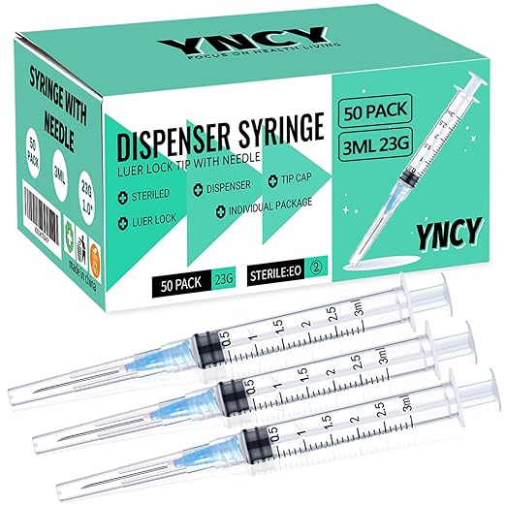

Injecting needles 50units Injecting needles 30 units
31 gauge 5/16” needle 31 gauge 5/16” needle
https://a.co/d/06hcgI2P https://a.co/d/0cGtf0N8

